[1]

E- Commerce For Artisans Named as HastKALA

Abhijeet Shivacharya,Shivang Singh,Geetanjali Shinde,Aishwarya Satpute And Prof.Archana Chaudhari

**Department of Instrumentation and Control Engineering**  .

***Abstract* —** Over 23 million artisans work in India's handicraft and handloom industries. A cross-border e-commerce marketplace will bring buyers and sellers together for business on a single platform. It will aid in the expansion of their businesses as well as the overall economy of our country. Summary: To create a one-of-a-kind e-commerce platform enabling artists to market their wares. Sentiment analysis with next suggested actions for the artist will be incorporated, as well as demand forecasting for the required products, automatic quality checks on the items, and sentiment analysis. Objective Providing a shared platform to manufacture, market, and sell high-quality handicrafts and items in order to promote the Indian handicraft industry abroad.

***Keywords*** *— Artisans , PHP , Handicraft ,Web-development,E-commerce*

# **INTRODUCTION**

A web-based shopping system for an established shop is Store With More.. The goal of the project is to turn an online shopping application into a web platform. Online shopping is the process of consumers purchasing goods or services directly from a vendor over the Internet in real time, without the use of an intermediary provider. It's a type of electronic trade. This project aims to provide customers of a physical store with the benefits of internet shopping. It allows you to buy things in a store from anywhere in the world using an Android mobile and the internet. As a result, the consumer will be able to shop online and have his purchases delivered to his home from his preferred store. Online shopping is a type of electronic commerce in which a buyer can buy things from a seller over the internet. Electronically and interactively in real-time, such as on Amazon.com for new books, the sale and buy transaction is accomplished. When there is an intermediary, the sell and purchase transaction is referred to as electronic commerce, such as online shopping. The major goal of introducing our food is to create a link between nature and technology, allowing customers to order fresh products directly from the farm via our website. Vendors who operate on a modest scale can expand their business from a local to a worldwide level. As we all know, farming is one of the top business plans in India, and anyone may start a farming business from a small scale to a large scale. However, the fundamental reason for the business's failure is that they all work in a manual fashion, such as with a pen and paper. It is uncommon to find any software installed on their farming operation.

**Literature Review**

According to Rohit Yadav et al. [5,] more clients can be attracted to online buying, and more profit can be made. Renee Garett et al. [6] argue that different organisations have varied needs, hence web design should be used to maximise profit. An online shopping website, for example, must concentrate primarily on the promotion of its many products and the facilitation of simple transactions, as well as security and appealing design. Punam Kumari et al. [7] discuss the necessity to expand the platform's web development languages so that users can choose the one that best suits their needs. Alla Moreva et al. [11] provide an excellent way of user testing utilising the eye-tracking method and an efficient procedure of website redisigning. Jitngernmadan, Prajaks [13] describe how to implement a website for science and technology faculty and later use this platform for the purpose of advertising of the institution to the students. .

# **Methodology**

**SYSTEM DESIGN**: This website is built mostly around the creation of modules in HTML5, CSS3, PHP, MYSQL, and JavaScript.

* **Sign In:** This is the process of becoming a customer or a seller. When a consumer or vendor becomes a registered member, they gain access to a number of benefits linked with the business.
* **Registering Login:** a user becomes a customer or vendor, and he or she can log in using their personal information.
* **Customer login**: When a customer logs in, he or she gains access to features such as buying products, updating carts, adding payment and shipping information, and so on.
* **Admin login**: When an admin logs in, he or she can perform tasks such as adding or removing customers, vendors, and products, viewing orders, and responding to user comments and suggestions.
* **Paymen**t:Payment is the final stage of any shopping website. The customer who is satisfied with their choice of product and price can now pay with card and cash on delivery.

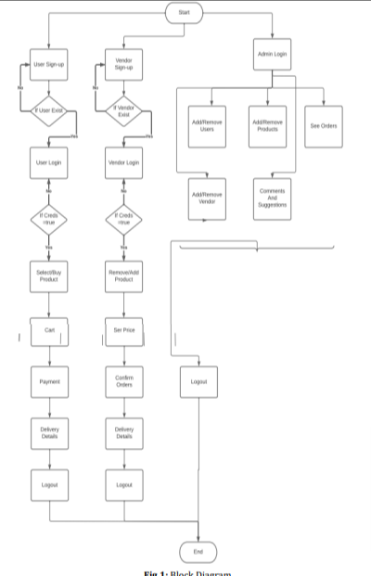

III. MODELING AND ANALYSIS

* *HTML5*

*The acronym HTML stands for Hypertext Markup Language. This is the language that is used to create web pages. It was released for the first time in 1993. Other languages such as CSS, PHP, JAVASCRIPT, and others can be used to create interactive and responsive pages using this language. Tags and attributes are the most common elements in HTML. HTML5 is simply a newer version of HTML.*

* *CSS3*

*Cascading Style Sheets (CSS) is the abbreviation for Cascading Style Sheets. CSS3 was released in 2011, and CSS was released in 1994. CSS is used to determine the look and feel of web pages, including the design, layout, and display variants for different devices and screen sizes. It is incredibly simple to use and comprehend.*

* *PHP*

*PHP is a web development-oriented general-purpose scripting language.*

*It was first designed by*

Rasmus Lerdorf, a Danish-Canadian programmer, in 1994. The PHP Group now produces the PHP reference implementation. PHP stands for Personal Home Page, however it is currently used to refer to the recursive initialism. PHP stands for Hypertext Preprocessor.

* MySQL

The acronym MySQL refers to the Structured Query Language. MySQL is a free database management system and a programming language for handling database data and records. It's a relational database management system (RDBMS). It's a high-performing software that can scale to meet user and data demands. MySQL is written in C and C++, making it compatible with the vast majority of operating systems.

* *JavaScript*

*JavaScript, sometimes known as JS, is a programming language that, along with HTML and CSS, is one of the essential technologies of the World Wide Web. On the client side, over 97 percent of websites employ JavaScript for web page behaviour, with third-party libraries frequently incorporated.*

# **Results and Discussions**

➢ **Registration web page**

Registration web page for the user to register the them as a customer.

Figure shows that the registration page:

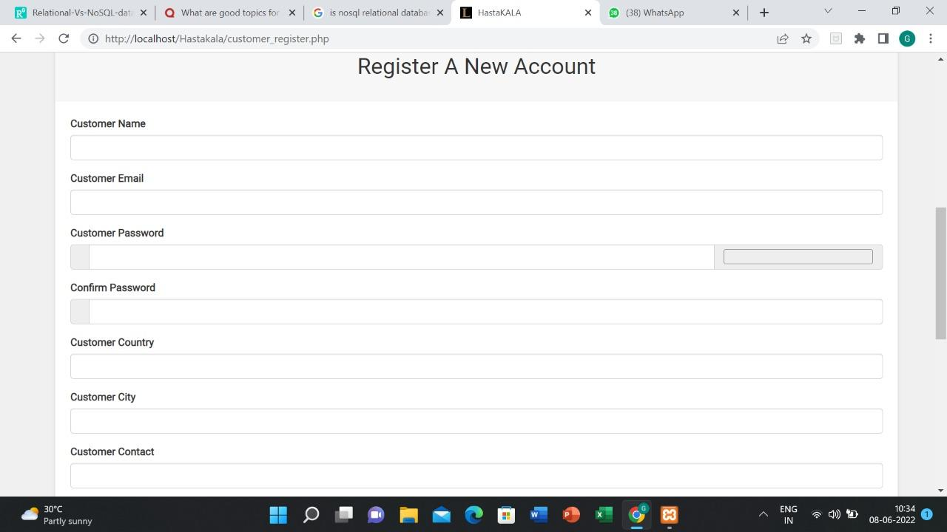

**➢ Login web page**

This is a screenshot of the login page, where customers can log in to the website using their email address and password.

Figure shows that the login page:

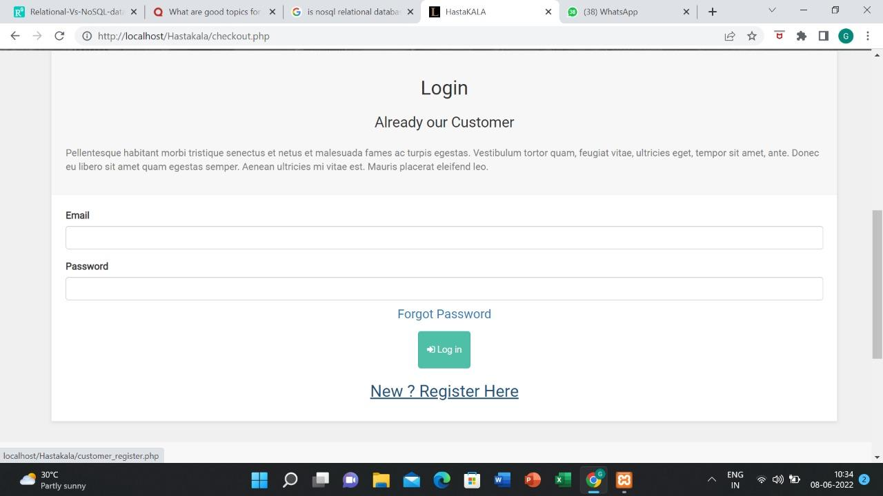

**➢ Product for the customer**

This is the product's webpage, and it is divided into sections such as vegetables, milk products, and so on.

Figure shows that the product in the website :

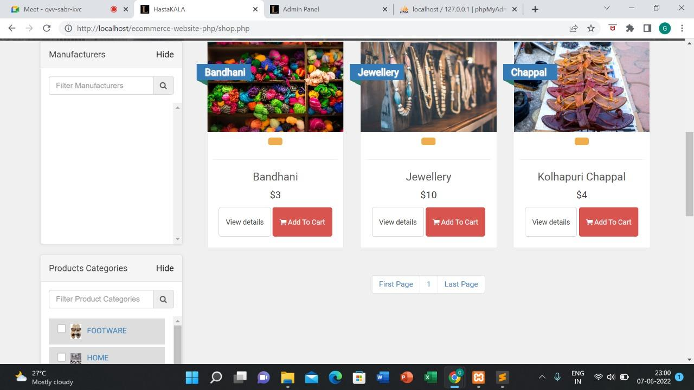

**➢ Selection Slider for the customer**

This is the left side slider for the product category, and this product is divided into sections such as Footer, Jewelry, and Wooden Craft.

Figure shows that left slider in the website

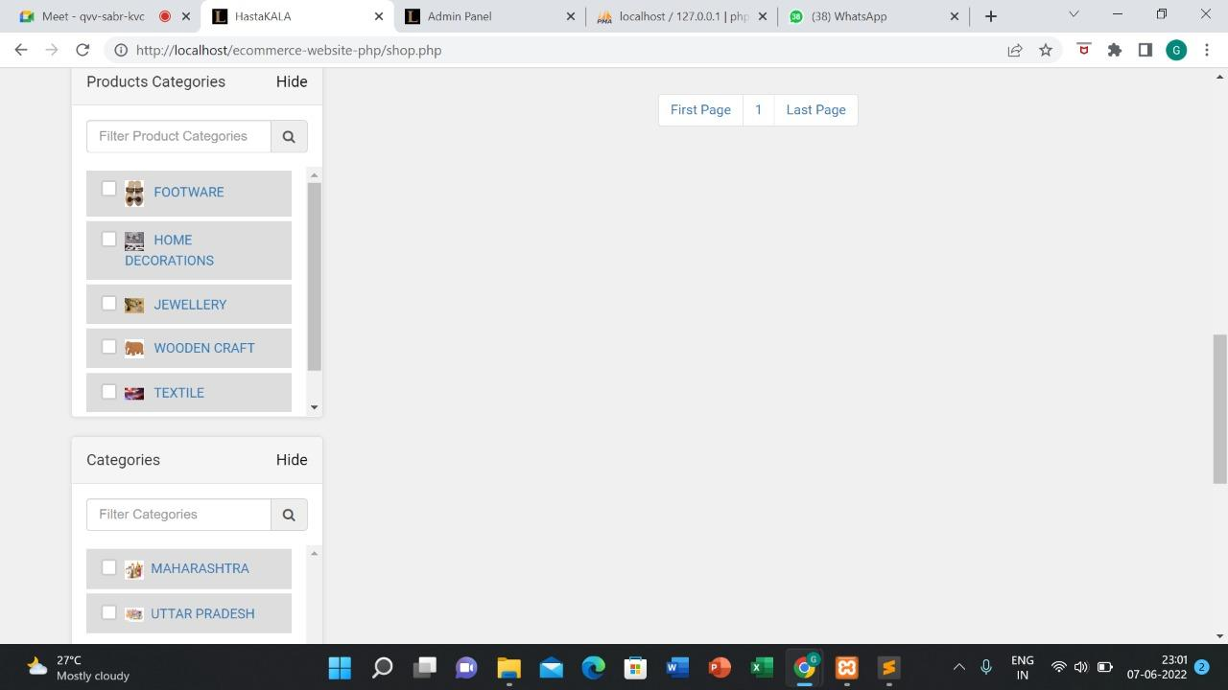

**➢Shopping Cart**

The customer can add the product to his or her My Card and edit it as needed..

Figure shows that the product is added into cart :

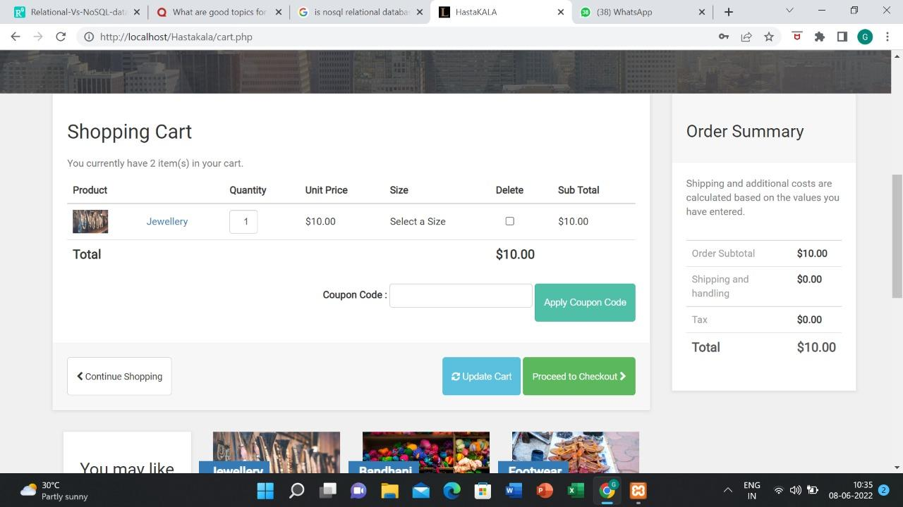

**➢Home Page**

A home page is the first page that a visitor sees when they arrive at a website via a search engine, and it can also be used as a landing page to attract visitors.

Figure shows Home Page :

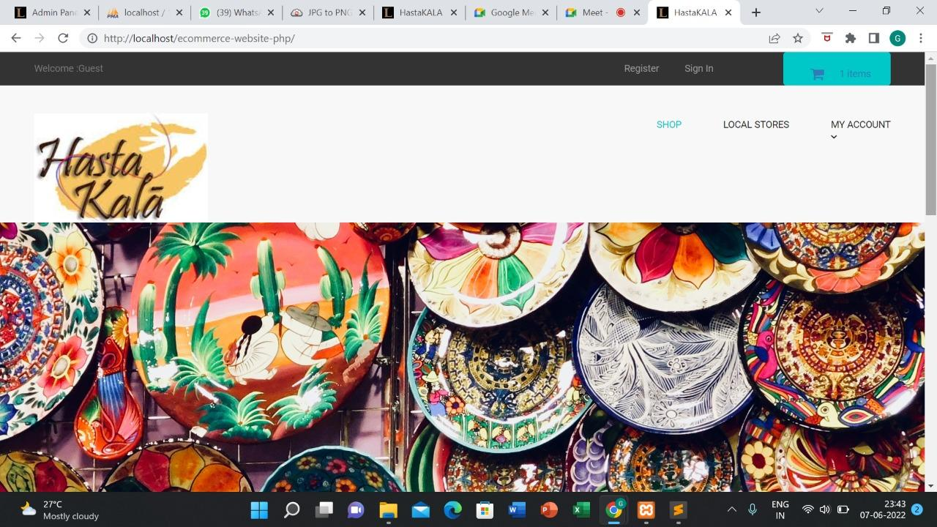

**➢Footer**

A footer contains information that improves the overall usability of a website.

Figure shows Footer :

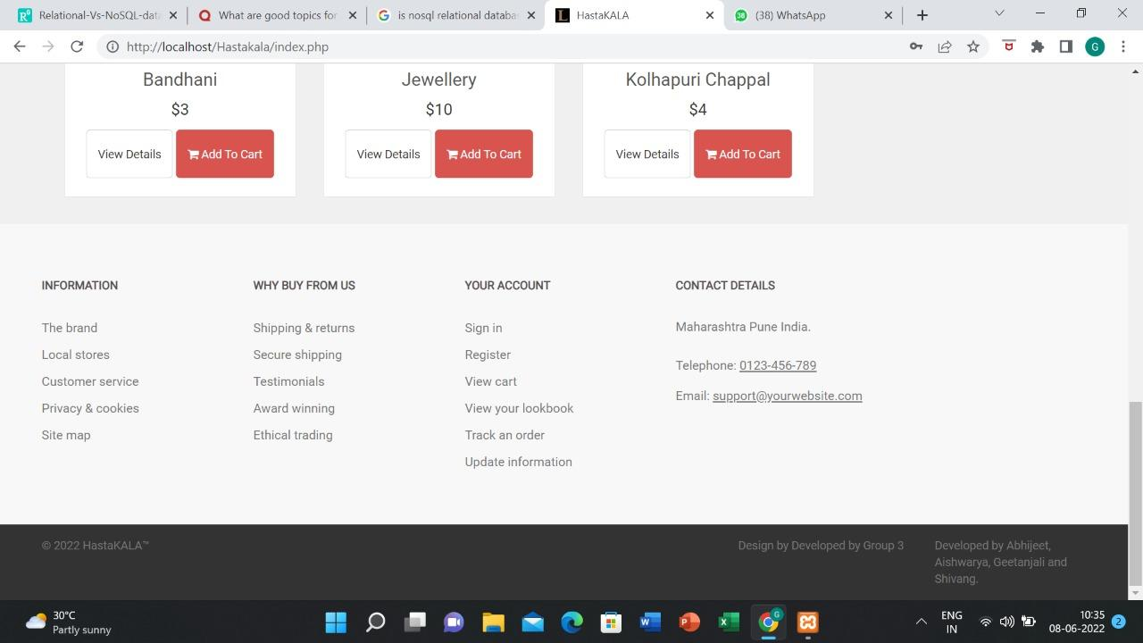

**➢Admin Panel**

The administration [admin] panel or screen allows you to manage a website's features, settings, and setup.

Figure shows Admin Panel :



# Future Scope

1. Scope - Small business Seller cannot use this for platform for Business by their own cause this website dose not contain enough functionality. Therefore in future we can implement this feature for common people
2. Bargaining system - This project does not contain a bargaining system yet, But in future this can be helpful for people to buy the handicraft with reasonable price

# Conclusion

This project's goal was to create a web application for buying handcrafted things. This project provided us with valuable information and practical experience on a variety of issues, including web page design using HTML and CSS, responsive template usage, and database management using PHP. In addition, the project taught us about project development phases and the software development life cycle. We learned how to put various aspects of a project to the test. This project has given us a lot of happiness because we were able to build an application that can be easily modified and installed in any neighbouring handicraft stores or local businesses selling a variety of products. In our project, there is a lot of room for improvement. We infer from this analysis that India has a significant potential for growth of a multibillion dollar ECommerce industry, as the top players in the market are growing at over 100% year on year and their values are in the billions of dollars.

References

1. https://www.researchgate.net/publication/313488649_Analysis_and_Practical_Application_of_PHP_Frameworks_in_Development_of_Web_Information_Systems
2. https://www.researchgate.net/publication/350789280_Concept_of_Web_Programming_An_Overview_of_PHP_Vol_1
3. http://www.diva-portal.org/smash/get/diva2:831188/FULLTEXT01.pdf.
4. https://www.ijrte.org/wp-content/uploads/papers/v8i3S/C10201083S19.pdf.
5. Rohit Yadav, Tripti Mahara, "An Empirical Study of Consumers Intention to Purchase Wooden Handicraft Items Online: Using Extended Technology Acceptance Model", Journal of Global Business Preview, July 3, 2017.
6. Renee Garett, Jason Chiu, Ly Zhang and Sean D. Young,"A Literature Review: Website Design and User Engagement", International Journal of Communication Media Technology,2016.
7. Punam Kumari and Rainu Nandal, "A Research paper on website Development Optimization using Xampp/PHP", International Journal of Advanced Research in Computer Science,2017
8. https://www.engpaper.com/cse/web-application-using-php.html.
9. <https://ptgmedia.pearsoncmg.com/images/9780321833891/samplepages/9780321833891.pdf>.
10. <https://www.irjmets.com/uploadedfiles/paper//issue_3_march_2022/19838/final/fin_irjmets1647360395.pdf>
11. Alla Moreva, Vitaly Kompaniets and Natalia Lyz, "Development and Oculographic Research of the Website Design Concept for Inclusive Education," Ural Symposium on Biomedical Engineering, Radioelectronics and Information Technology (USBEREIT), Yekaterinburg, Russia,pp. 276-279,2019
12. <https://ijcsit.com/docs/Volume%205/vol5issue02/ijcsit20140502328.pdf>
13. Prajaks Jitngernmadan and Prawit Boonmee, "Key Factors of Usability of Science and Technology Faculties’ Website: Marketing Purpose," 4th International Conference on Information Technology (InCIT), Bangkok, Thailand, pp. 289-293, 2019
14. <https://digitalcommons.wou.edu/cgi/viewcontent.cgi?article=1008&context=fac_pubs>
15. https://iopscience.iop.org/article/10.1088/1742-6596/1804/1/012079/pdf

1.